SUBRACTION OF NUMBERS

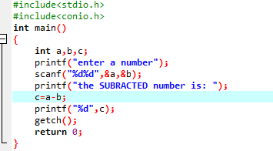

OUTPUT

